DATES TO REMEMBER
June
Mon 10 | Queen’s Birthday holiday
Tue 11 | Pupil Free day
Fri 14 | Whitten Oval excursion (3 – 6)
Mon 17 | School Council meeting 6pm
Tue 18 | Bulldogs HQ excursion (3 – 6)
Wed 19 | Responsible Pet Ownership (all)
Thu 20 | Library Excursion (Bulldogs Read)
Thu 27 | African Drumming return session
Thu 27 | Pie Drive collection day
Fri 28 | Last day of term – 2.30pm finish
Dear Parents and Community Members,

We have had a good week at school this week, with the children continuing their end of semester assessments. Those are nearly all complete now, barring a few catch-ups due to absence, and we will get them done next week. Teachers will be spending this weekend beginning their semester reports which will come home to you at the end of term.

Next week the children have 2 extra days at home. Queen’s birthday is on Monday and we are pupil free on Tuesday for report writing. On Wednesday afternoon the children will all be voting in the Warrenheip PS general election to decide who will be Prime Minister for the day at the end of term and what activities we will be doing that day!

Election fever has well and truly gripped the students as they decide between the “Fun and Games” party, the “Extreme Day” party or the “Anything and Everything” party. Whoever wins, the candidates and political parties have done a great job of their campaigns so far!

Could all parents please note that we have had an outbreak of head lice reported at school. Please check your children’s hair and treat them if required. Remember that nits can take up to a week to hatch so you need to continue treatment for a long time to be sure of getting all the lice and eggs. Children should not come to school until treatment has been started.

Don’t forget to get your pie drive forms in to school next week – Friday 14th is the cut off day. Deliveries will be made on Thursday 27 July (second last day of term).

Coming home this week is the permission form for two excursions for the grade 3 – 6 children. These are both part of the Bulldogs Read program and both are covered by the one form. Please get these back to us as soon as you can.

Due to the very short week next week I will not be writing a newsletter next week. The next newsletter will be on Friday 21 June, so please remember the notes and dates that you need between now and then. One date that I will remind you of is the next school council meeting which is scheduled for Monday 17 June at 6pm.

Friday 21 will also be the next hot lunch day (and the last for the term) – a hot lunch order form will come home either next Friday or the following Monday.

Thank you very much to all of you who have returned your permission forms for the Whitten Oval excursion next week. If you have not got around to it please return the form as soon as you can, as time is very short now. Don’t forget that children in Grades 3 – 6 need to be at school at 7.30am next Friday. Mrs Tromp will be taking the children to Melbourne while I stay here with the younger students.

Have a great weekend,
Arthur Lane

? Weekly Puzzle ?
What’s missing?
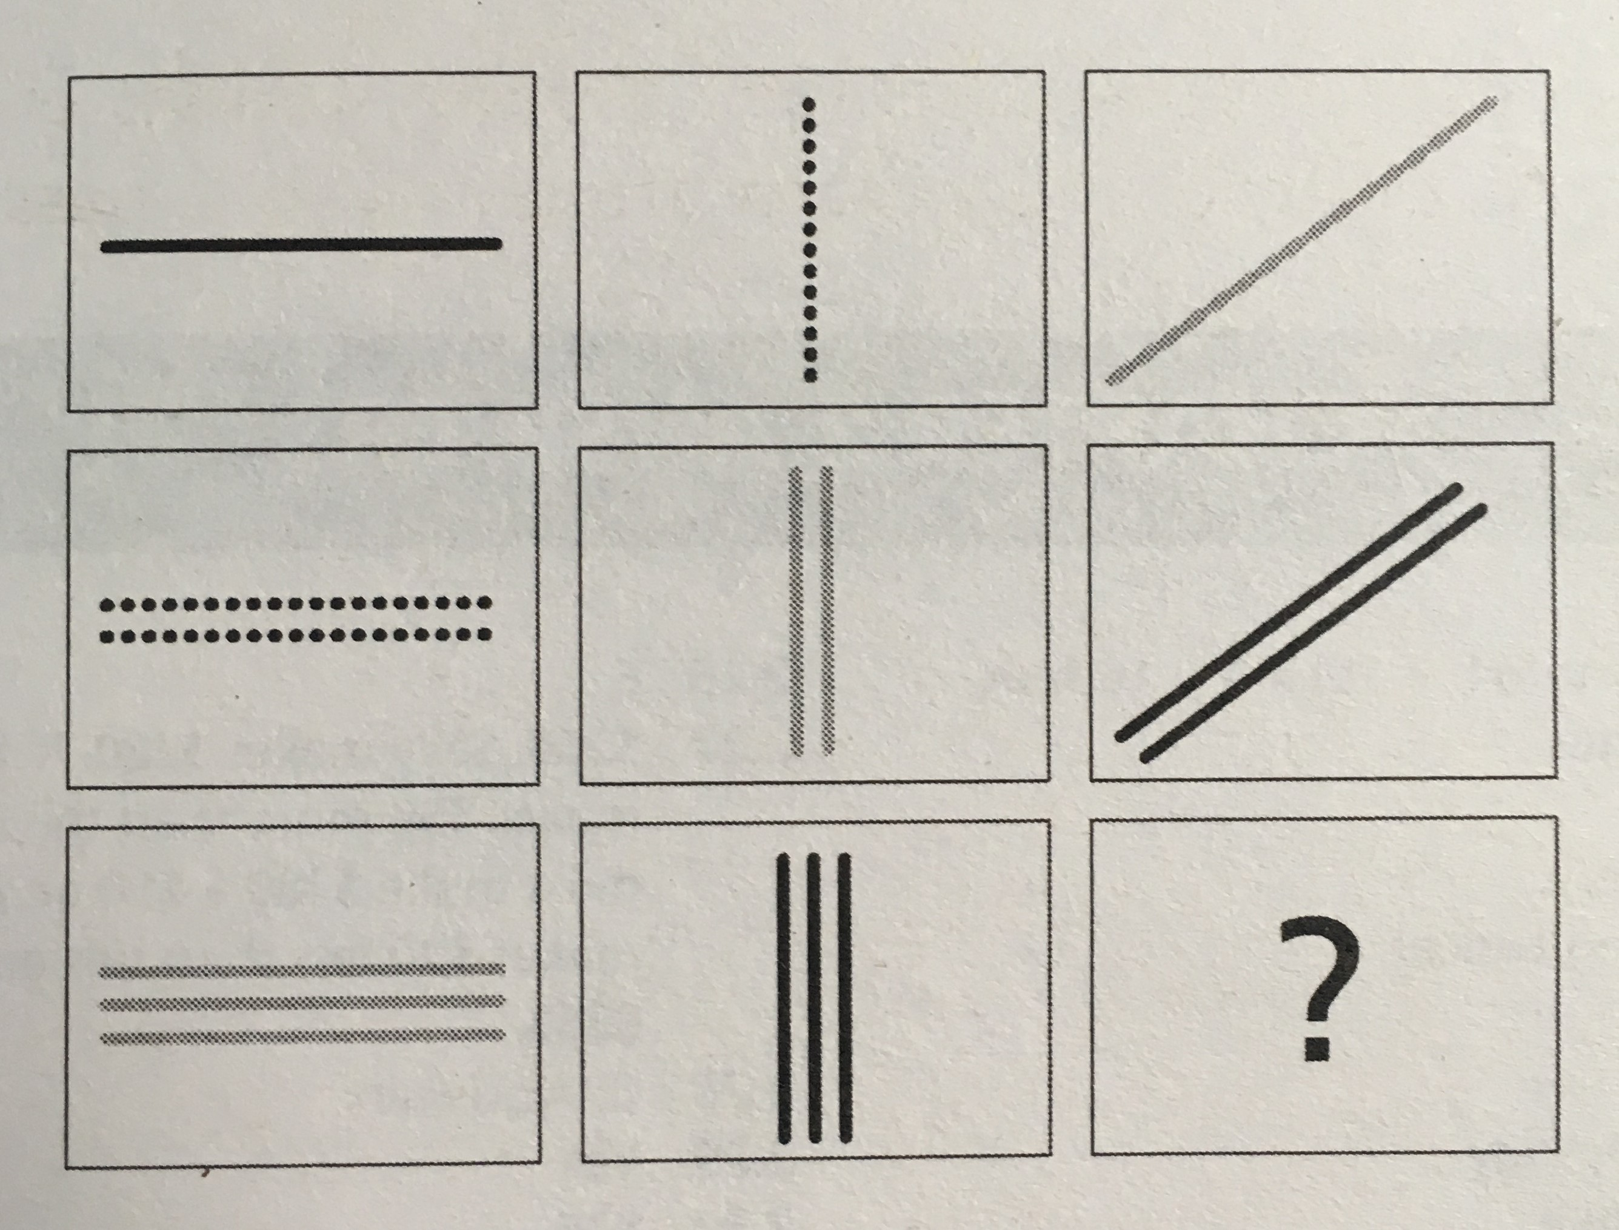
Last week’s winner: Joel

